**Cyber complaint Management System**

**A MINI-PROJECT REPORT**

***Submitted by***

**R PAVITAJEY– 2116220701195**

in partial fulfilment of the award of the degree

of

# BACHELOR OF ENGINEERING

**IN**

**COMPUTER SCIENCE AND ENGINEERING**



# RAJALAKSHMI ENGINEERING COLLEGE

**AUTONOMOUS, CHENNAI**

## NOV/DEC, 2024

### BONAFIDE CERTIFICATE

Certified that this mini project “**Cyber complaint Management System**” is the bonafide work of “**R PAVITAJEY (2116220701195)”** who carried out the project work under my supervision.

| **SIGNATURE:** |
| --- |
| **Mrs. JANANEE V,** |
| Assistant Professor, |
| Computer Science & Engineering |
| Rajalakshmi Engineering College |
| Thandalam, Chennai -602105. |

Submitted for the End semester practical examination to be held on 

**INTERNAL EXAMINER EXTERNAL EXAMINER**

### ACKNOWLEDGEMENT

I express my sincere thanks to my beloved and honourable chairman **MR.S.MEGANATHAN** and the chairperson **DR.M.THANGAM MEGANATHAN** for their timely support and encouragement.

I am greatly indebted to my respected and honourable principal **Dr. S.N.MURUGESAN** for his able support and guidance.

No words of gratitude will suffice for the unquestioning support extended to us by my head of the department **Dr. P. KUMAR,** and my Academic Head **Dr.N.DURAIMURUGAN,** for being ever supporting force during my project work.

I also extend my sincere and hearty thanks to my internal guide **Mrs. JANANEE V** for her valuable guidance and motivation during the completion of this project.

My sincere thanks to my family members, friends and other staff members of Computer Science and Engineering.

R PAVITAJEY 2116220701195

## ABSTRACT

In today's increasingly digital world, cybercrimes are on the rise, including hacking, identity theft, phishing, and online harassment. The **Cyber Complaint Management System (CCMS)** is a web-based platform designed to provide citizens with an efficient and secure method for reporting cybercrimes. The system streamlines the process of filing, managing, and tracking cyber complaints, providing law enforcement agencies with tools to resolve these complaints effectively. This paper presents the system's scope, objectives, architecture, and implementation, along with the hardware and software specifications required for its deployment.

### TABLE OF CONTENTS

| CHAPTER NO | TABLE | PAGE NO |
| --- | --- | --- |
| **ABSTRACT** |  |  |
| 1 | **INTRODUCTION** | 6 |
| 2 | **SYSTEM SPECIFICATIONS** | 8 |
| 3 | **ARCHITECTURE DIAGRAM** | 9 |
| 4 | **MODULE DESCRIPTION** | 10 |
| 5 | **SAMPLE CODING** | 18 |
| 6 | **SCREEN SHOTS** | 28 |
| 7 | **CONCLUSION** | 30 |
| 8 | **REFERENCES** | 31 |

## CHAPTER 1

### INTRODUCTION

**1. INTRODUCTION**

The growth of the internet has brought with it a surge in cyber-related crimes. The existing systems for reporting and managing such crimes are often cumbersome, leading to delays in addressing critical issues. The **Cyber Complaint Management System (CCMS)** is developed to provide users with an easy-to-use interface for reporting cybercrimes and monitoring the progress of their complaints. This system enables authorities to categorize, prioritize, and resolve complaints more efficiently. By leveraging modern web technologies, CCMS aims to make the cybercrime reporting process seamless and more effective.

**1.2 SCOPE OF THE WORK**

The scope of the **Cyber Complaint Management System** includes:

* Providing a secure platform for users to register and submit cybercrime complaints.
* Enabling authorities to categorize, assign, and investigate complaints.
* Allowing users to track the status of their complaints through a unique ID.
* Maintaining a database of all complaints for statistical and analytical purposes.
* Implementing user-friendly interfaces for both complainants and administrators.
* Ensuring data privacy and security throughout the process, from complaint submission to resolution.

**1.3 AIM AND OBJECTIVES OF THE PROJECT**

The primary aims and objectives of the CCMS are:

* To streamline the complaint submission and management process for cybercrime victims.
* To provide law enforcement agencies with a centralized system for tracking and resolving complaints.To enhance the response time to cybercrime complaints through better prioritization and categorization.
* To ensure the security of sensitive data, including user information and evidence submitted with complaints.
* To offer a transparent system where users can easily monitor the progress of their complaints.

### CHAPTER 2

### SYSTEM SPECIFICATIONS

1. **HARDWARE SPECIFICATIONS**

Processor **:** Pentium IV Or Higher

Memory Size **:** 128 GB (Minimum)

HDD **:** 40 GB (Minimum)

1. **SOFTWARE SPECIFICATIONS**

| Operating System | **:** | WINDOWS 7 AND PLUS |
| --- | --- | --- |
| Front – End | **:** | HTML, CSS, |
| Back – End | **:** | PHP, MYSQL |

**CHAPTER 3**

**ARCHITECTURE DIAGRAM**

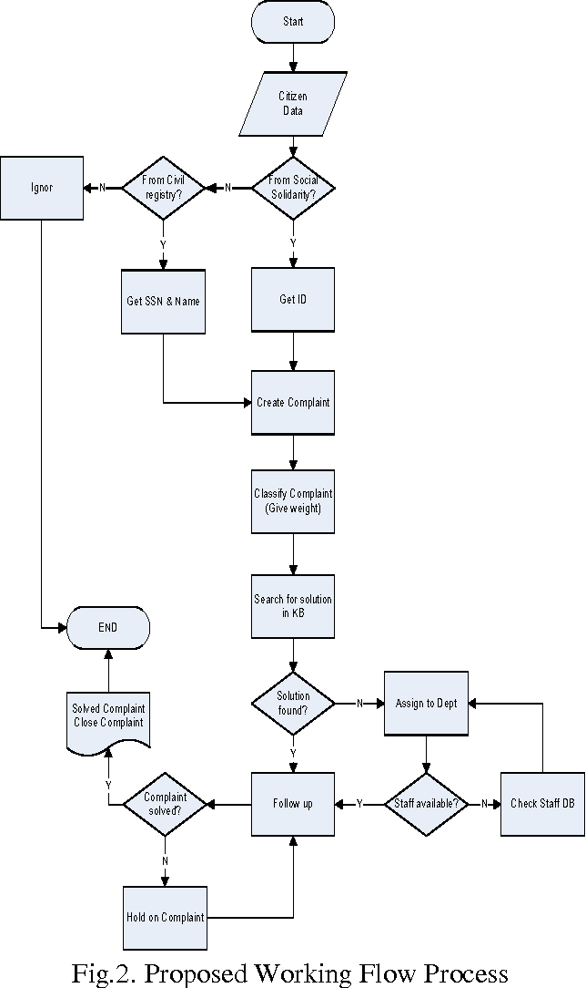

**CHAPTER 4**

**MODULE DESCRIPTION**

The system is divided into various modules, each focusing on a specific task to ensure the seamless functioning of the CCMS.

#### 4.1. User Management Module

* **Description:** This module allows users to register, log in, and manage their profiles. Users can reset passwords and update their contact information.
* **Key Features:** Registration, Login, Password Reset, Profile Management.

#### 4.2. Complaint Submission Module

* **Description:** This module provides users with a structured form to submit cybercrime complaints. It also allows the upload of supporting evidence such as screenshots or documents.
* **Key Features:** Complaint Form, Evidence Upload, Complaint ID Generation.

#### 4.3. Complaint Management Module

* **Description:** Law enforcement or administrative users access this module to review, categorize, assign, and update complaints. They can set priorities, mark cases as resolved, and communicate with users for additional information.
* **Key Features:** Complaint Review, Status Updates, Case Assignment, Priority Setting.

#### 4.4. Tracking and Notification Module

* **Description:** Users can track the progress of their complaints through a unique complaint ID. The system sends notifications to users via email or SMS when the status of their complaint changes.
* **Key Features:** Complaint Status Tracking, Email/SMS Notifications.

#### 

#### 

#### 4.5. Reporting Module

* **Description:** This module generates reports for administrative users, providing insights into complaint types, resolution times, and the overall system performance.
* **Key Features:** Report Generation, Statistical Analysis, Data Export.

# CHAPTER 5

**SYSTEM DESIGN**

**5.1 USE CASE DIAGRAM**

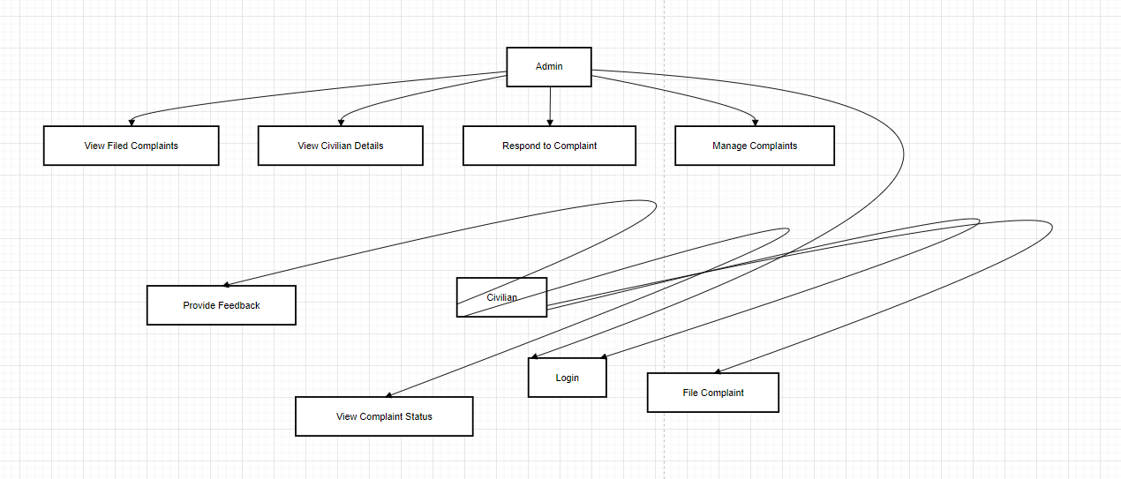

**5.2 ER DIAGRAM**

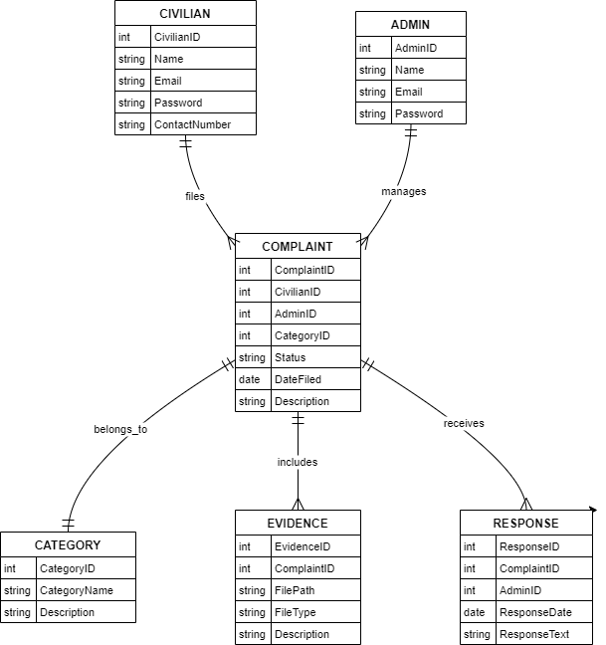

**5.3. DFD DIAGRAM**

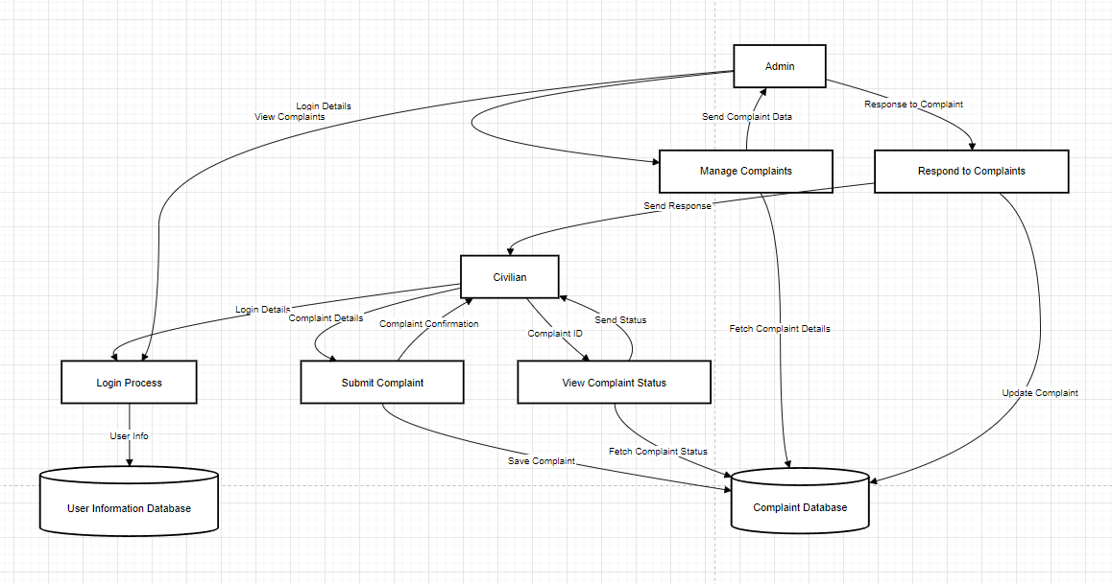

**5.3.1. FIRST LEVEL DFD**

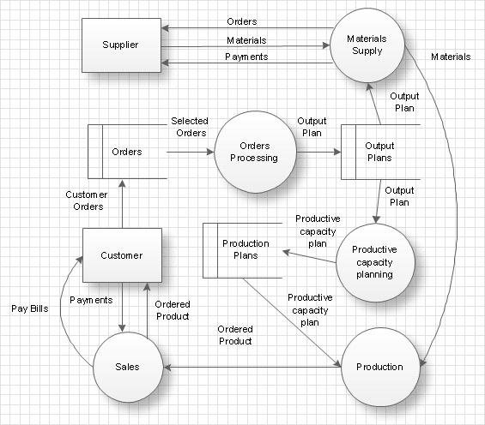

**5.3.2. SECOND LEVEL DFD**

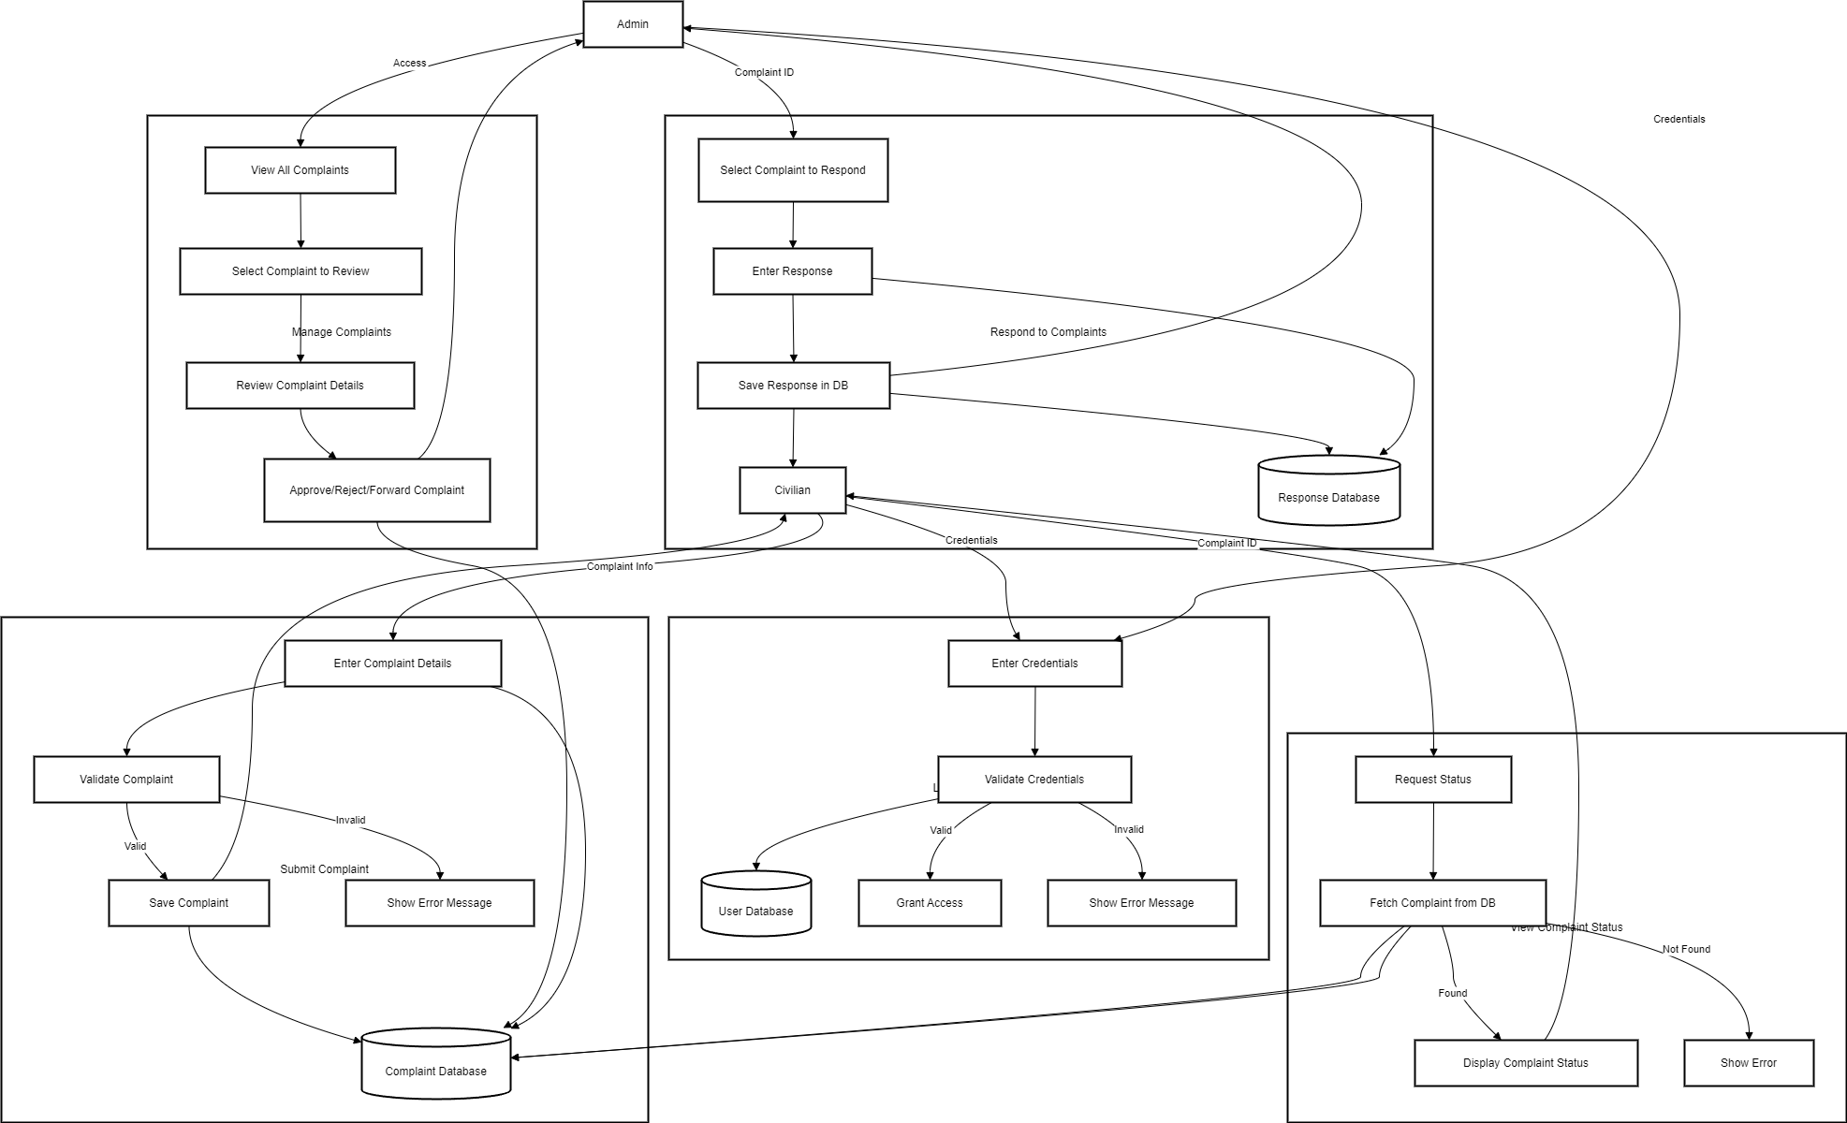

**5.4. ACTIVITY DIAGRAM**

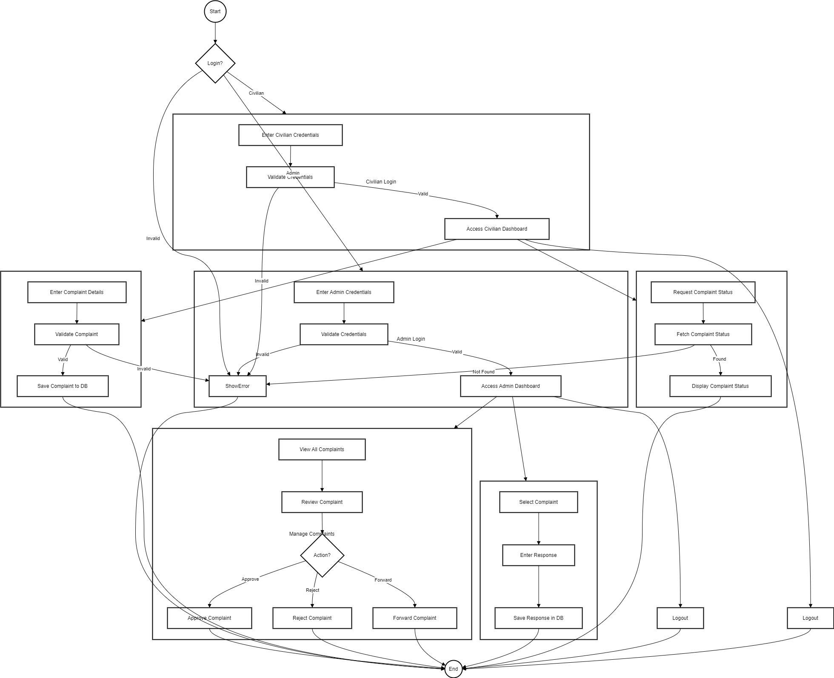

## CHAPTER 6

## SAMPLE CODING

<!DOCTYPE html>

<html lang="en">

<head>

<meta charset="UTF-8">

<meta name="viewport" content="width=device-width, initial-scale=1.0">

<title>Cyber Crime Records Management System</title>

<style>

* {

margin: 0;

padding: 0;

box-sizing: border-box;

}

body {

font-family: 'Arial', sans-serif;

line-height: 1.6;

background-color: #f4f4f4;

overflow-x: hidden;

}

/* Video background */

.video-background {

position: fixed;

top: 0;

left: 0;

width: 100%;

height: 100%;

object-fit: cover;

z-index: -1;

opacity: 100; /* Optional: Make the video slightly transparent */

}

.nav {

background: transparent;

color: #228B22;

height: 70px;

display: flex;

justify-content: space-between;

align-items: center;

padding: 0 40px;

transition: background-color 0.3s ease-in-out;

}

.nav:hover {

background-color: #faf6f6;

}

.nav .nav-title {

font-size: 28px;

font-weight: bold;

transition: transform 0.3s;

}

.nav-title:hover {

transform: scale(1.1);

}

.nav-menu ul {

list-style: none;

display: flex;

gap: 30px;

}

.nav-menu ul li {

color: #228B22;

font-size: 18px;

cursor: pointer;

position: relative;

transition: color 0.3s ease-in-out;

}

.nav-menu ul li:hover {

color: #fff;

font-weight: bold;

}

.nav-menu ul li a {

color: inherit;

text-decoration: none;

}

.nav-menu ul li a::before {

content: '';

position: absolute;

width: 0;

height: 2px;

background-color: #fff;

bottom: -2px;

left: 0;

transition: width 0.3s;

}

.nav-menu ul li a:hover::before {

width: 100%;

}

/* Login button in navigation bar */

/* Login button in navigation bar */

.login-button-nav {

padding: 10px 20px;

background-color: #e2e2e2; /* Changed to black */

color: white;

text-decoration: none;

border-radius: 5px;

font-size: 16px;

transition: background-color 0.3s ease-in-out;

}

.login-button-nav:hover {

background-color: #333; /* Dark gray on hover */

}

/* Extra Login button at bottom */

.login-button {

display: inline-block;

padding: 10px 20px;

background-color: #000; /* Changed to black */

color: white;

text-decoration: none;

border-radius: 5px;

font-size: 16px;

transition: background-color 0.3s ease-in-out;

text-align: center;

margin: 20px auto;

display: block;

}

.login-button:hover {

background-color: #333; /* Dark gray on hover */

}

@media (max-width: 768px) {

.nav {

flex-direction: column;

height: auto;

padding: 10px 20px;

}

.nav-title {

font-size: 22px;

text-align: center;

}

.nav-menu ul {

flex-direction: column;

gap: 15px;

padding: 10px 0;

}

}

section {

padding: 60px 20px;

max-width: 1200px;

margin: 0 auto;

}

h3 {

text-align: center;

font-size: 28px;

margin-bottom: 40px;

color: #f7f3f3;

transition: color 0.3s ease-in-out;

}

h3:hover {

color: #228B22;

}

table {

width: 100%;

border-spacing: 20px;

margin-bottom: 40px;

}

table td {

vertical-align: top;

padding: 15px;

}

table img {

width: 100%;

height: auto;

border-radius: 8px;

box-shadow: 0 4px 8px rgba(0, 0, 0, 0.1);

transition: transform 0.3s;

}

table img:hover {

transform: scale(1.05);

}

td h2 {

color: #228B22;

font-size: 24px;

text-align: center;

margin-bottom: 15px;

}

td p, td ul {

font-size: 16px;

line-height: 1.8;

color: #ece8e8;

}

td ul {

margin-top: 15px;

padding-left: 20px;

}

td ul li {

margin-bottom: 10px;

}

.footer {

background-color: #f8f4f4;

color: #228B22;

text-align: center;

padding: 15px;

position: relative;

transition: background-color 0.3s ease-in-out;

}

.footer:hover {

background-color: #f7f5f5;

}

.footer p {

margin: 0;

font-size: 14px;

}

.accordion {

background-color: #f9f9f9;

border: 1px solid #ddd;

border-radius: 4px;

margin: 20px 0;

}

.accordion-header {

background-color: #faf9f9;

color: #228B22;

cursor: pointer;

padding: 15px;

font-size: 18px;

font-weight: bold;

transition: background-color 0.3s ease-in-out;

}

.accordion-header:hover {

background-color: #968f8f;

}

.accordion-content {

display: none;

padding: 15px;

background-color: white;

}

.accordion-content p {

font-size: 16px;

color: #968f8f;

}

/* Extra Login button at bottom */

.login-button {

display: inline-block;

padding: 10px 20px;

background-color: #228B22;

color: white;

text-decoration: none;

border-radius: 5px;

font-size: 16px;

transition: background-color 0.3s ease-in-out;

text-align: center;

margin: 20px auto;

display: block;

}

.login-button:hover {

background-color: #006400;

}

@media (max-width: 768px) {

table td {

display: block;

text-align: center;

margin-bottom: 20px;

}

table img {

width: 80%;

margin: 0 auto;

}

}

</style>

</head>

<body>

<!-- Video Background -->

<video class="video-background" autoplay muted loop>

<source src="your-video-url.mp4.mp4" type="video/mp4">

Your browser does not support the video tag.

</video>

<div class="nav">

<div class="nav-title">TAMILNADU CYBER CRIME</div>

<div class="nav-menu">

<ul>

<li><a href="#one">Home</a></li>

<li><a href="#two">Online Awareness</a></li>

<li><a href="#three">Important Links</a></li>

<li><a href="#four">General Tips</a></li>

<li><a href="loginselect.html" class="login-button-nav">Login</a></li> <!-- Added Login button here -->

</ul>

</div>

</div>

<div class="hero">

<h1></h1>

</div>

<section id="two">

<h3>Online Awareness</h3>

<table>

<tr>

<td>

<h2>HACKING</h2>

<p>Hacking is the unauthorized access or manipulation of computer systems, networks, and data, often for malicious purposes such as data theft, financial gain, or system disruption. As technology evolves, so do the techniques used by hackers, ranging from phishing and malware to sophisticated attacks like Distributed Denial of Service (DDoS) and ransomware. Cybersecurity, therefore, becomes essential in protecting sensitive information and maintaining system integrity. Key defenses include using strong, unique passwords, multi-factor authentication (MFA), encryption, and constant monitoring for vulnerabilities. Education on online threats, robust security infrastructures, and rapid response protocols are crucial for individuals and organizations to mitigate the risks of hacking and cybercrime in an increasingly digital world.</p>

</td>

</tr>

<tr>

<td>

<h2>CREDIT CARD FRAUD</h2>

<p>**Credit Card Fraud** refers to the unauthorized use of someone’s credit card information to make purchases or withdraw funds. It is one of the most common types of financial crime in the digital age, often resulting from data breaches, phishing attacks, or card skimming. Fraudsters may steal card details through hacking, malware, or even by physical theft of the card itself. The rise of online shopping and digital payments has increased the risk of credit card fraud, prompting businesses and individuals to adopt enhanced security measures such as encryption, tokenization, and multi-factor authentication to protect sensitive data. Prevention and rapid detection are critical to minimizing losses and ensuring financial security.</p>

</td>

</tr>

</table>

</section>

<section id="three">

<h3>Important Links</h3>

<table>

<tr>

<td>

<h2>GET TO KNOW ABOUT CYBERSECURITY</h2>

<a href="https://www.britannica.com/topic/cybercrime" target="_blank">

<img src="ARCTI.jpeg" alt="Mumbai Police" style="width: 150px; margin-left:200px; height: 150px;">

</a>

</td>

<td>

<h2>GET DAILY CYBER NEWS</h2>

<a href="https://www.bbc.com/news/topics/c1xp19421ezt" target="_blank">

<img src="bbc.png" alt="Tamil Nadu Police" style="width: 150px; margin-left:150px; height: 150px;">

</a>

</td>

</tr>

</table>

</section>

<section id="four">

<h3>General Tips</h3>

<div class="accordion">

<div class="accordion-header">Password Protection</div>

<div class="accordion-content">

<p>Use strong, unique passwords for different accounts. Consider using a password manager to store them securely.</p>

</div>

</div>

<div class="accordion">

<div class="accordion-header">Software Updates</div>

<div class="accordion-content">

<p>Keep your operating system, browser, and other software up to date to protect against vulnerabilities.</p>

</div>

</div>

<div class="accordion">

<div class="accordion-header">Be Wary of Phishing Scams</div>

<div class="accordion-content">

<p>Be cautious of emails and messages asking for personal information or urging immediate action.</p>

</div>

</div>

</section>

<!-- Additional Login button at the bottom -->

<a href="loginselect.html" class="login-button">Login</a>

<script>

// Accordion functionality

const headers = document.querySelectorAll('.accordion-header');

headers.forEach(header => {

header.addEventListener('click', () => {

const content = header.nextElementSibling;

content.style.display = content.style.display === 'block' ? 'none' : 'block';

});

});

</script>

</body>

</html>

### CHAPTER 7

#### Screen Shots

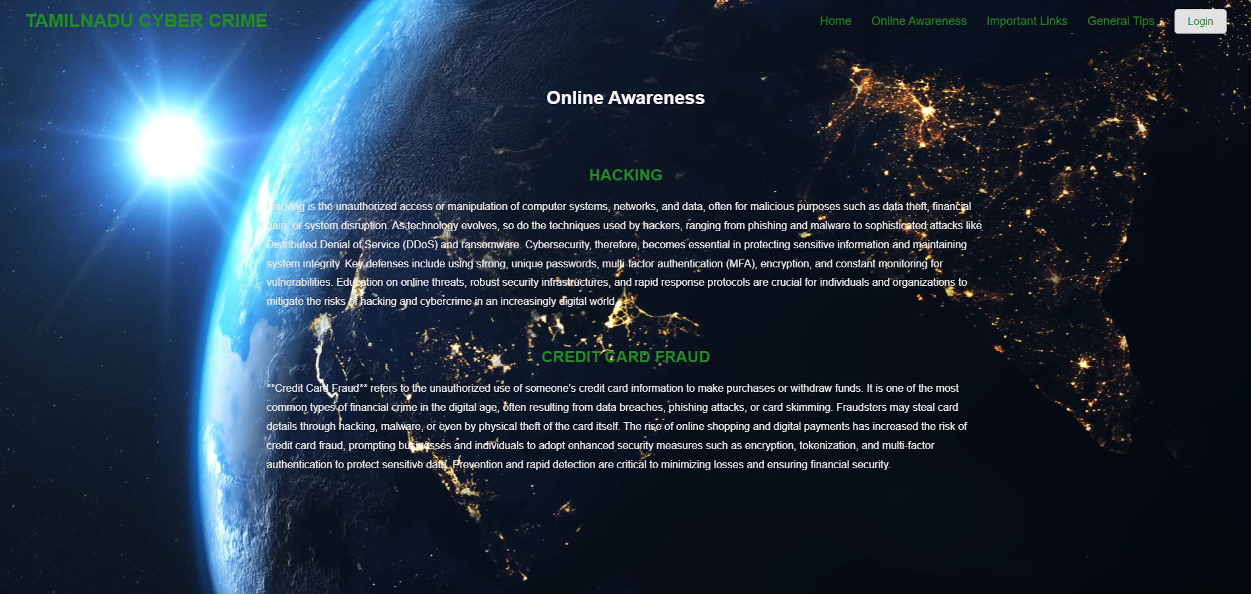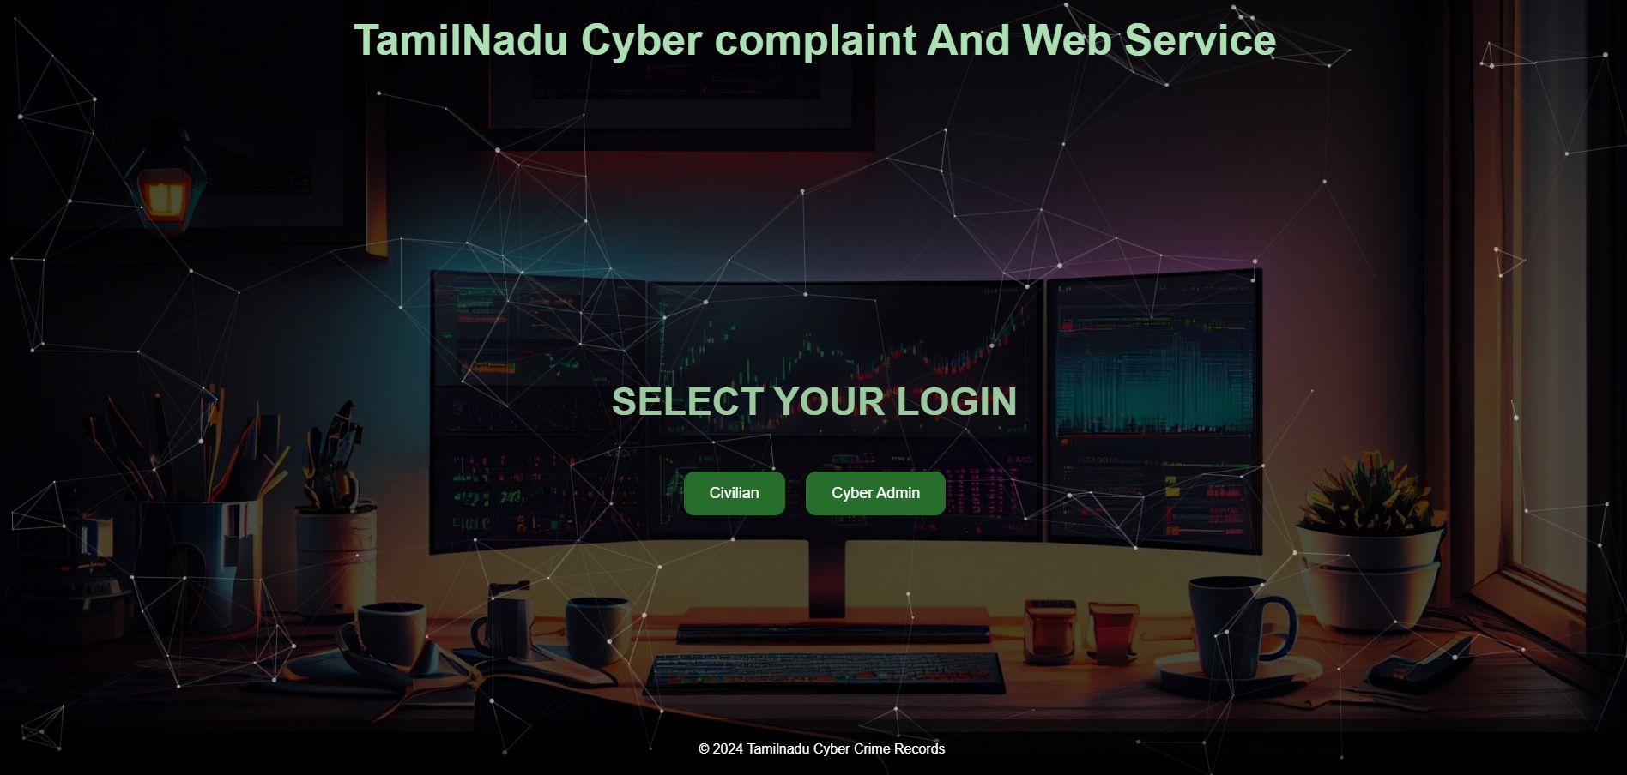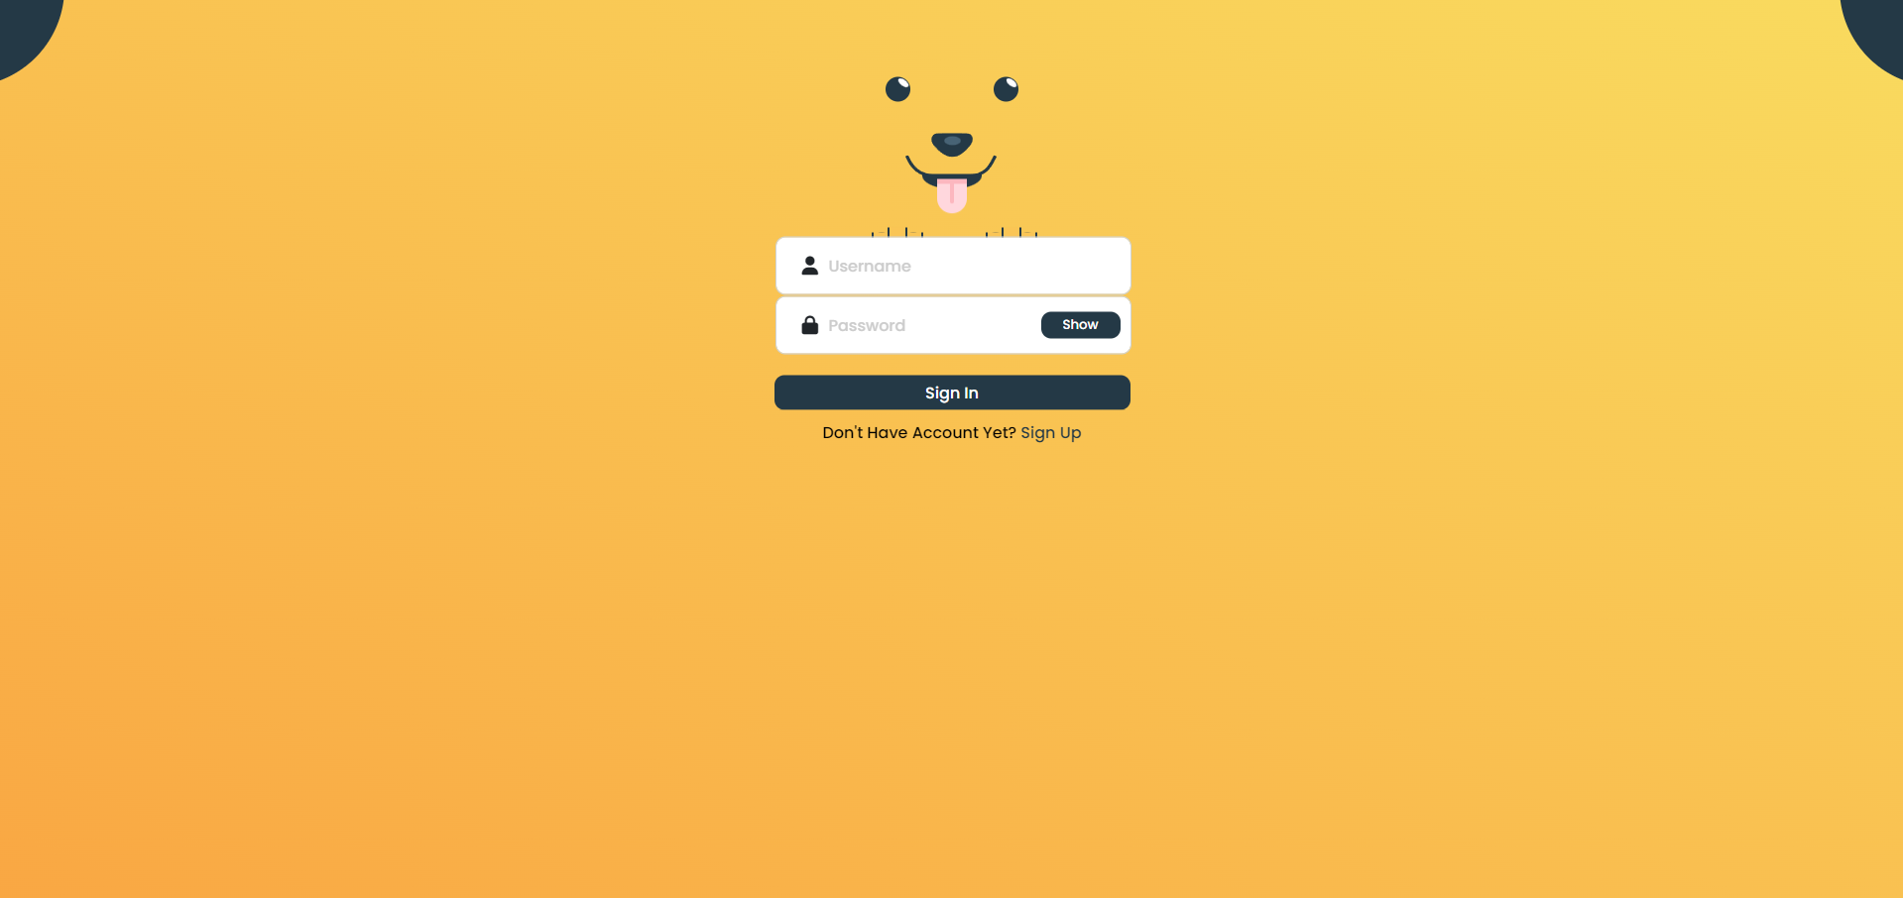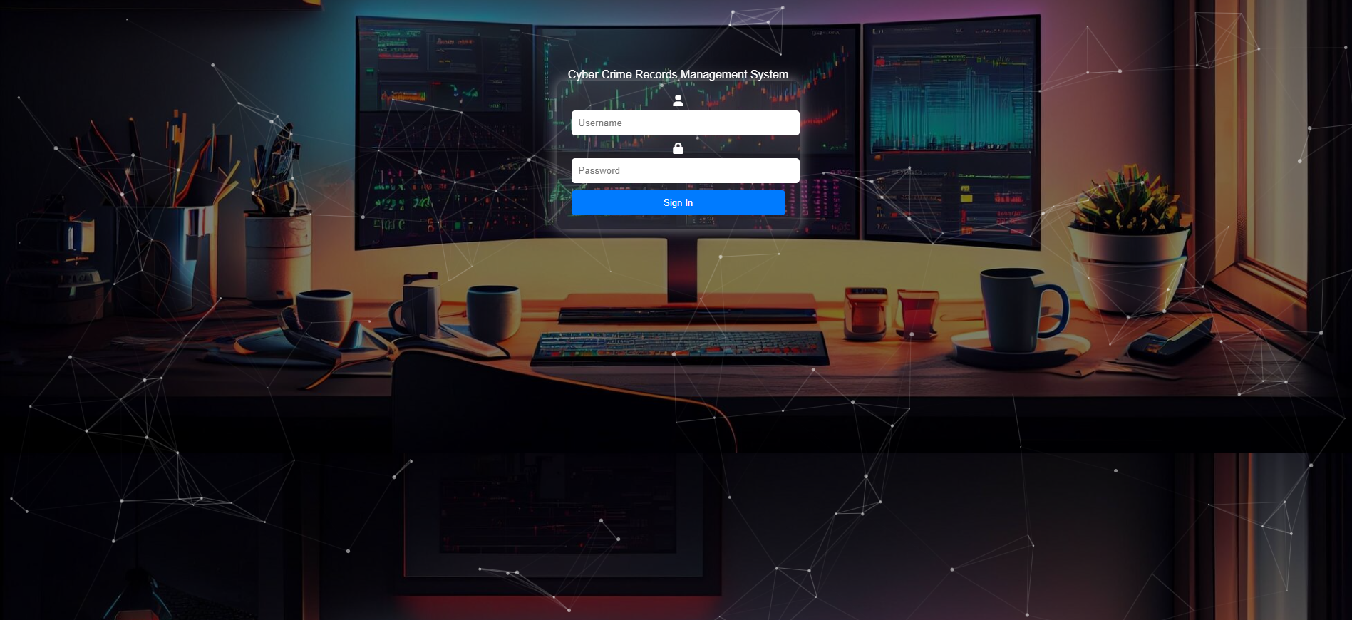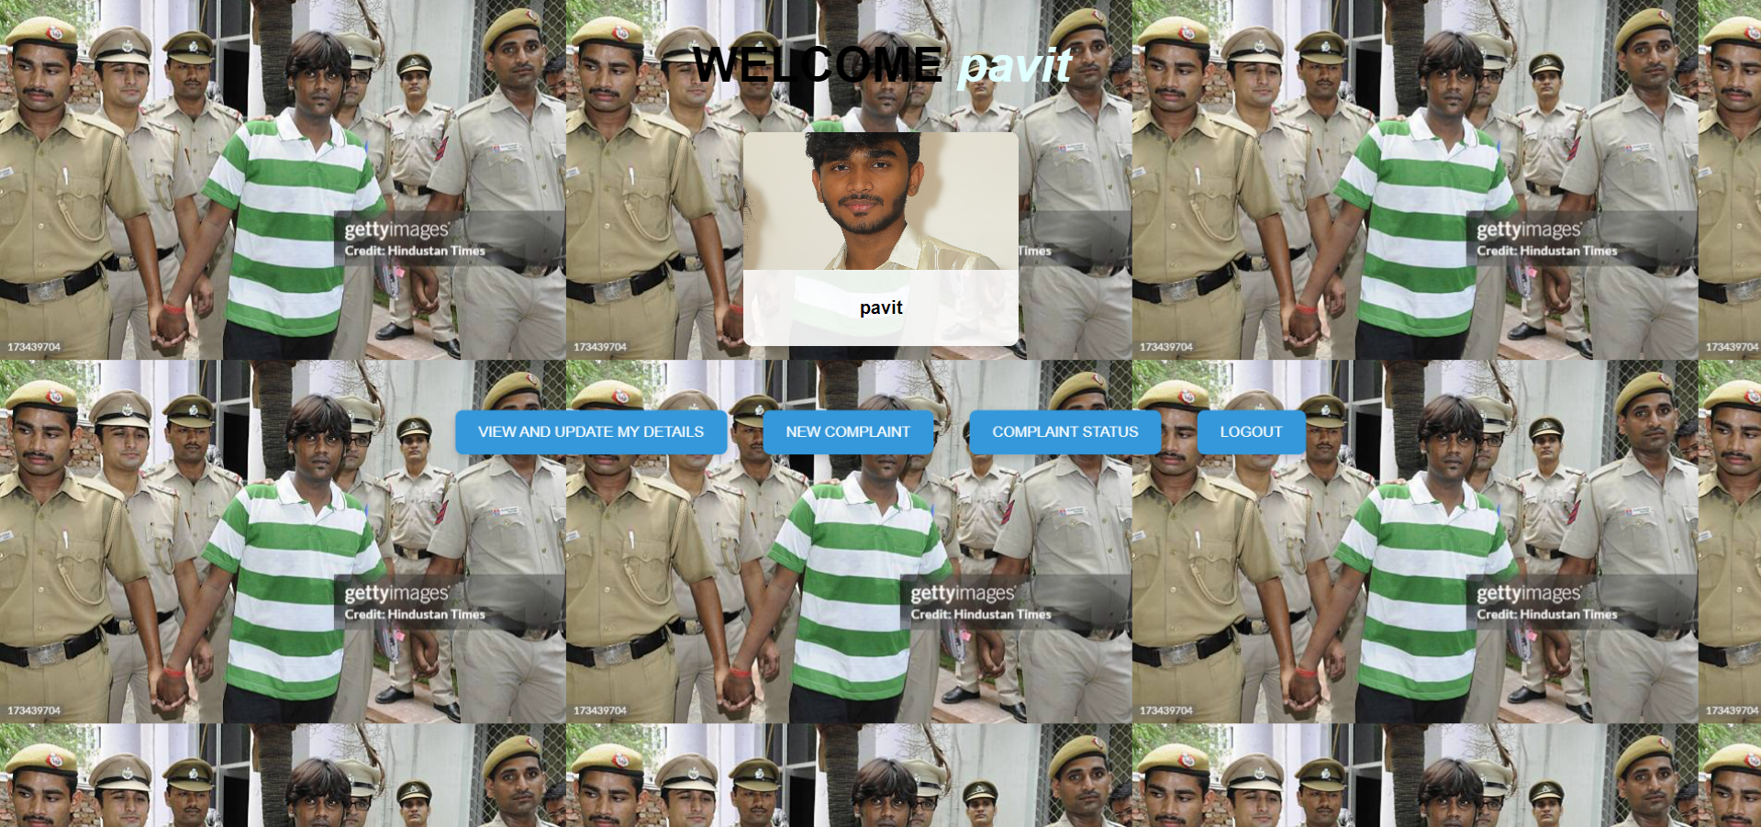

### CHAPTER 8

#### CONCLUSION

## The Cyber Complaint Management System (CCMS) offers a comprehensive solution to address the growing challenge of managing cybercrime complaints. With the increasing prevalence of cyber-related offenses, traditional methods of handling complaints often prove inefficient, resulting in delayed responses and unresolved cases. The CCMS fills this gap by providing a structured, user-friendly platform that allows individuals to report cybercrimes quickly and securely.

## One of the key strengths of the CCMS lies in its seamless integration of various components, including user management, complaint submission, tracking, and real-time notifications. The system’s architecture is designed to ensure high performance, scalability, and security, making it adaptable to the needs of both users and law enforcement agencies. The use of modern web frameworks, secure authentication mechanisms, and a robust database ensures that sensitive information is protected, and data privacy is maintained throughout the process.

## By offering a clear workflow from complaint submission to resolution, the CCMS enhances transparency and builds trust between users and authorities. Citizens are no longer left in the dark about the status of their complaints, as the system provides them with real-time updates and a means to track progress using a unique complaint ID. This improves user satisfaction and confidence in the authorities' ability to handle cybercrime cases effectively.

## For law enforcement agencies, the CCMS streamlines case management by allowing officers to categorize, prioritize, and assign complaints based on the severity of the issue. With detailed reporting tools, authorities can also analyze trends, identify common cybercrime patterns, and take proactive measures to address emerging threats. Furthermore, the system reduces the administrative burden on officers, allowing them to focus more on investigations and less on manual data management.

## The system’s modular design enables future enhancements, such as the integration of artificial intelligence (AI) for automated complaint categorization and priority assessment. It also opens opportunities for developing mobile applications that will allow users to file and track complaints on-the-go. These potential improvements can further increase the efficiency of the system and provide more convenient access for users.

## In conclusion, the Cyber Complaint Management System not only modernizes the process of reporting and managing cybercrimes but also strengthens the overall cybercrime response infrastructure. Its ability to efficiently handle complaints, secure sensitive information, and provide transparency in the complaint process makes it an invaluable tool in combating the growing threat of cybercrimes. As the system evolves, its integration with new technologies and mobile platforms will further enhance its capabilities, ensuring it remains an essential resource for users and law enforcement agencies alike.

## REFERENCES

1. HTML , CSS , JS – [www.w3schools.com](http://www.w3schools.com)
2. PHP, MYSQL – [www.youtube.com](http://www.youtube.com/)
3. Carousel Slider – [www.glidejs.com](http://www.glidejs.com/)
4. Font Awesome Icons – [www.fontawesome.com](http://www.fontawesome.com/)
5. PHP Mailer - <https://github.com/PHPMailer/PHPMailer>